NAME =CHINTHA DINESH

GMAIL= [dineshchitha8@gmail.com](mailto:dineshchitha8@gmail.com)

SOURCE =SQL

DATA= PIZZASALES

1Q. SELECT SUM(TOTAL_PRICE)AS TOTAL_REVENUE FROM PIZZA_SALES

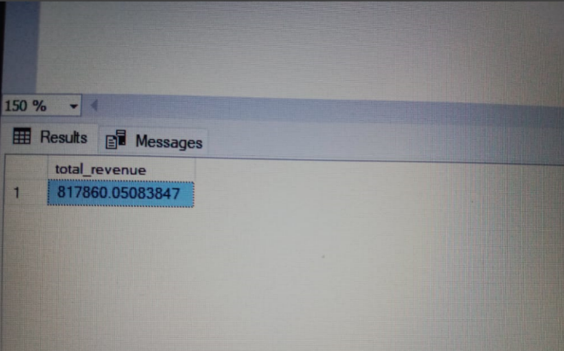

2Q. SELECT SUM(TOTAL_PRICE) / COUNT (DISTINCT ORDER_ID )AS TOTAL_AVG_ORDERS FROM PIZZA_SALES

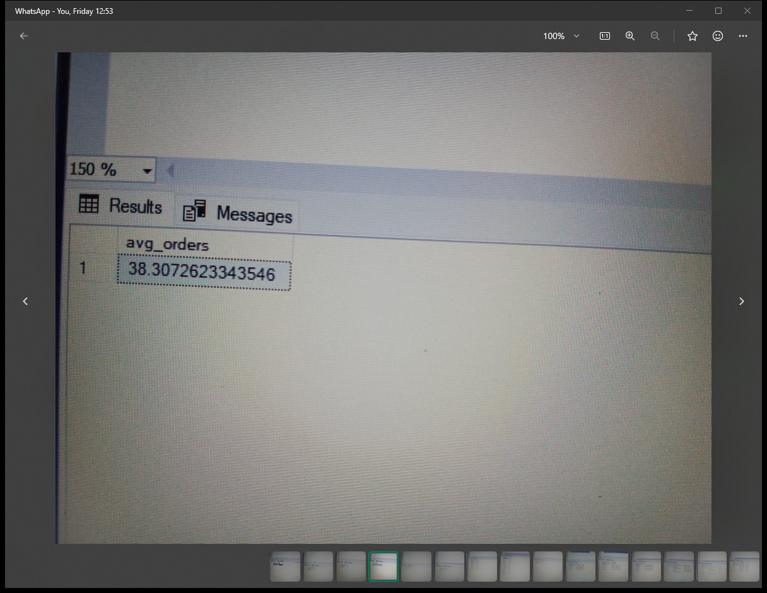

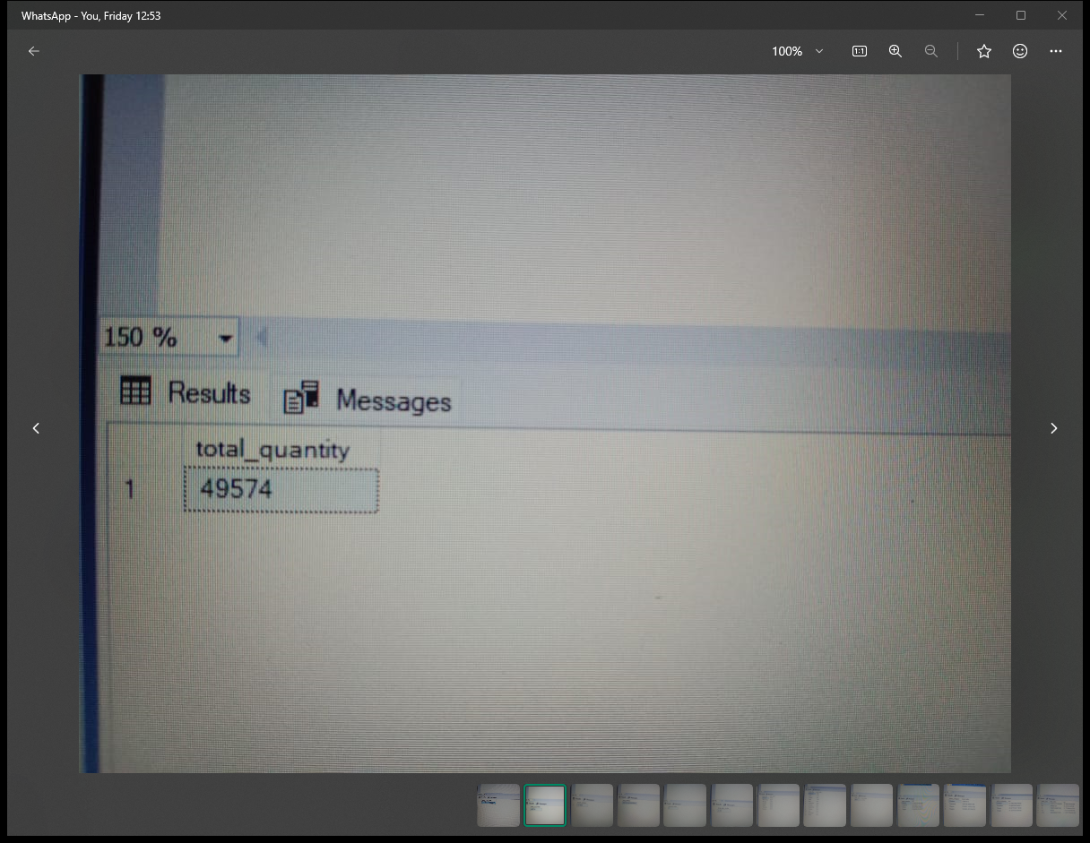3Q. SELECT SUM(QUANTITY)AS TOTAL_QUANTITY FROM PIZZA_SALES

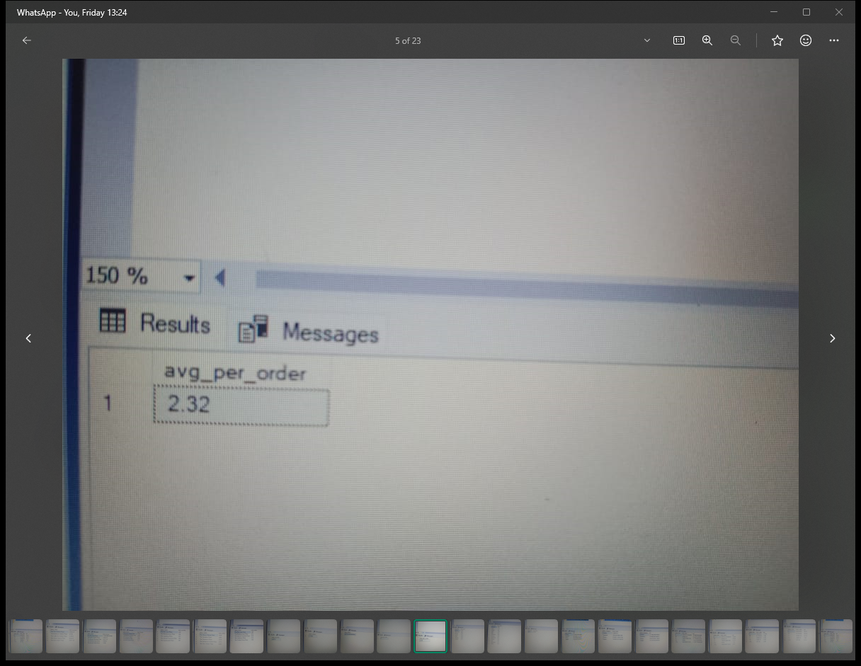

4Q. SELECT COUNT (DISTINCT ORDER_ID )AS TOTAL_ORDERS FROM

PIZZA_SALES

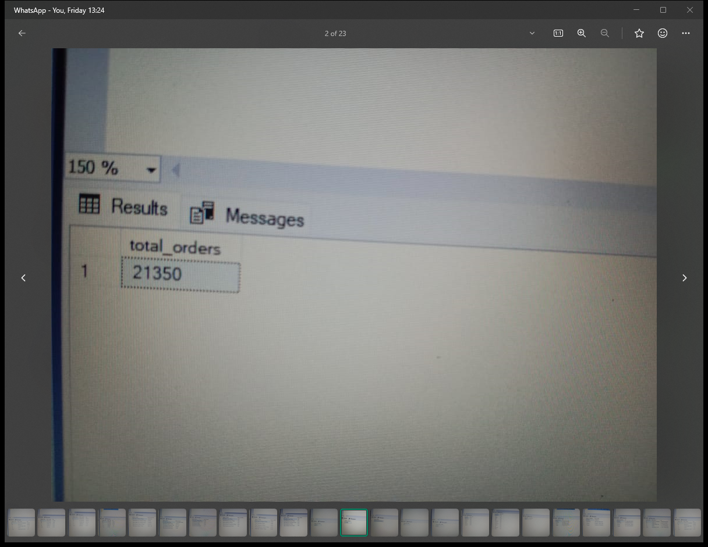



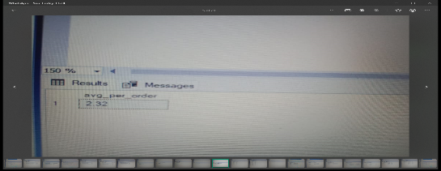

5Q. . SELECT CAST(CAST( SUM(QUANTITY)AS DECIMAL(10,2)) / COUNT (DISTINCT ORDER_ID )AS DECIMAL(10,2))/TOTAL_AVG_ PER _ORDERS FROM PIZZA_SALES



6Q. SELECT DATENAME(DW,ORDER_DATE)AS ORDER_DAY, COUNT(DISTINCT ORDER_ID) AS TOTAL _ORDERS FROM PIZZA_SALES

GROUP BY DATENAME(DW, ORDER_DATE)

ORDER BY TOTAL_ORDERS DESC

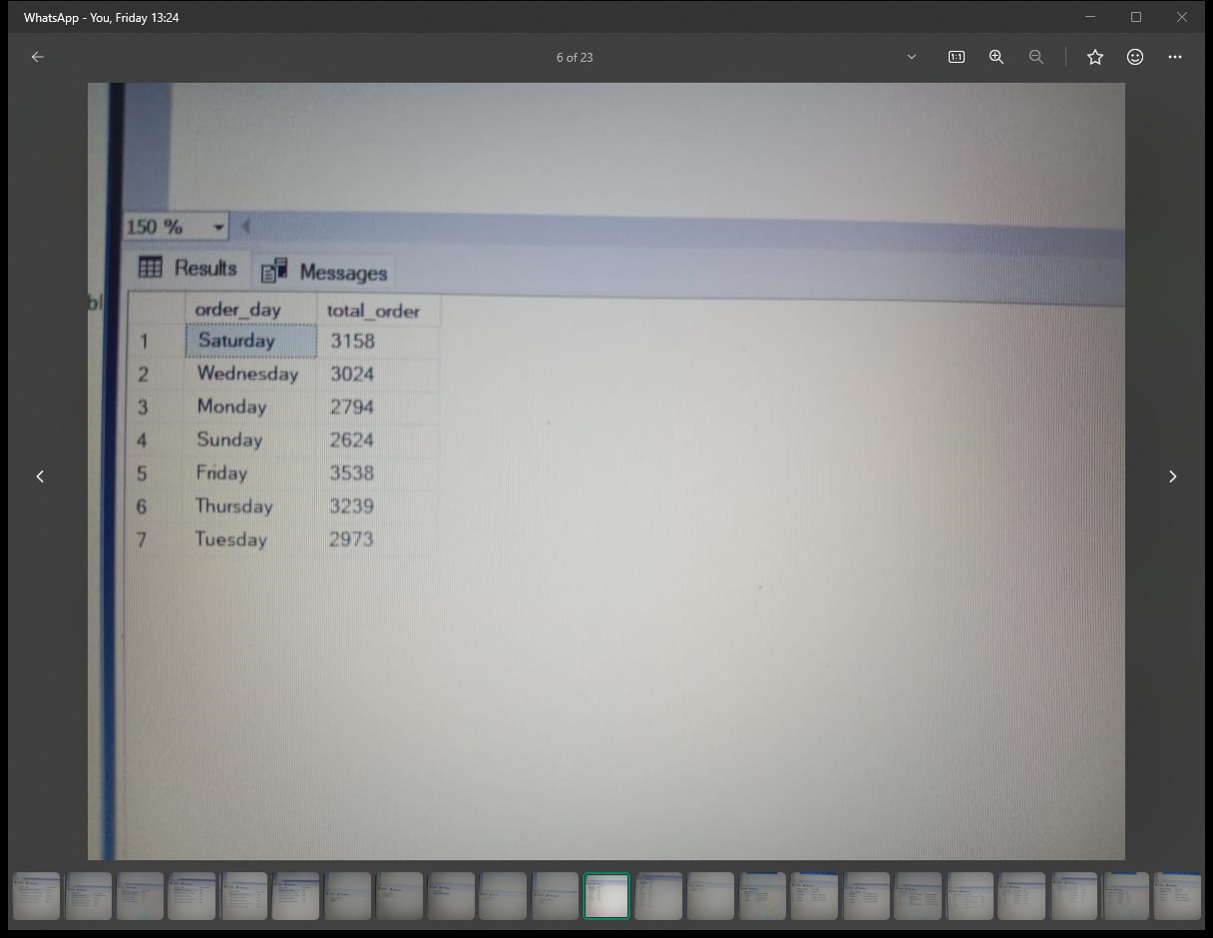

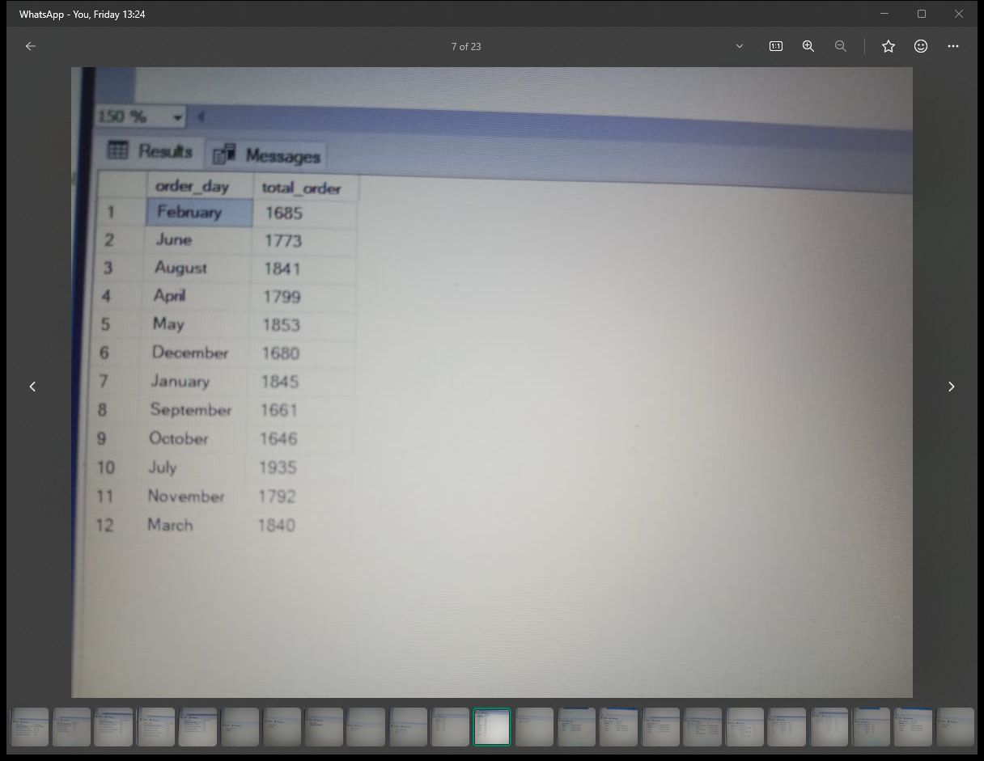7Q. SELECT DATENAME(MONTH,ORDER_DATE)AS ORDER_DAY, COUNT(DISTINCT ORDER_ID) AS TOTAL _ORDERS FROM PIZZA_SALES

8Q. . SELECT DATENAME(YEAR,ORDER_DATE)AS ORDER_DAY, COUNT(DISTINCT ORDER_ID) AS TOTAL _ORDERS FROM PIZZA_SALES

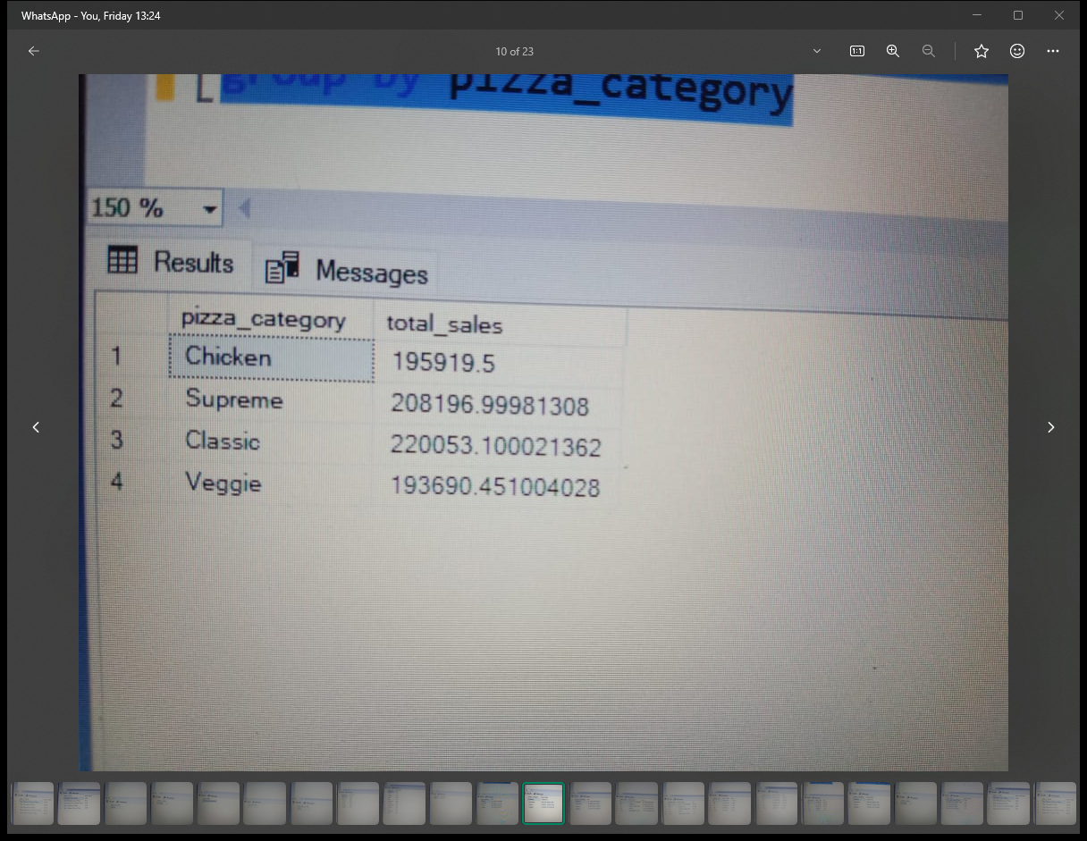

9Q.SELECT PIZZA_CATEGORY, SUM (TOTAL_PRICE)AS TOTAL _SALES, SUM(TOTAL_PRICE)*100/(SELECT SUM(TOTAL_PRICE) FROM PIZZA_SALES )AS PCT FROM PIZZA-SALES

GROUP BY PIZZA_CATEGORY

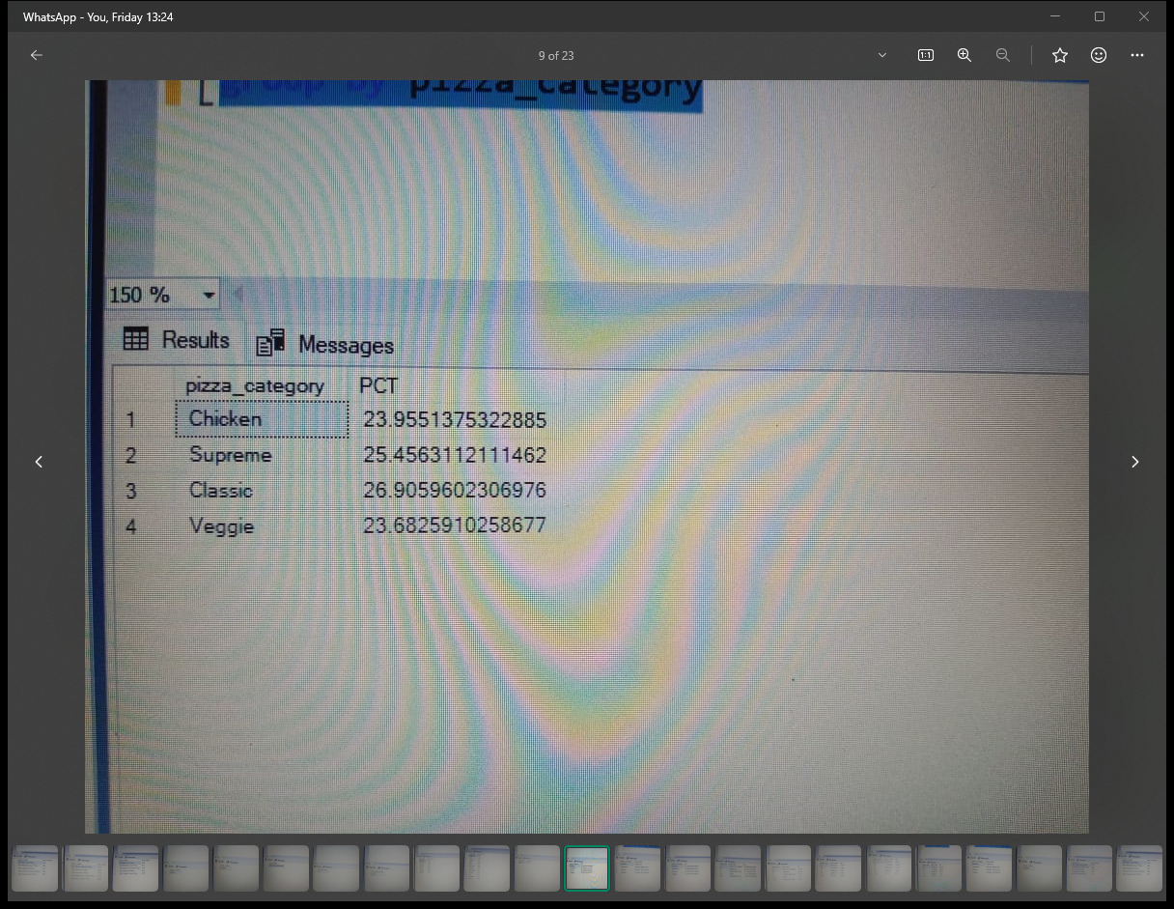

PERC

TOTAL SALES

10Q. SELECT PIZZA_SIZE, SUM (TOTAL_PRICE)AS TOTAL _SALES, CAST(SUM(TOTAL_PRICE)*100/(SELECT SUM(TOTAL_PRICE) FROM PIZZA_SALES )AS DECIMAL(10,2)AS PCT FROM PIZZA-SALES

WHERE DATEPART(QUARTER,ORDER_DATE)=1

GROUP BY PIZZA_SIZE

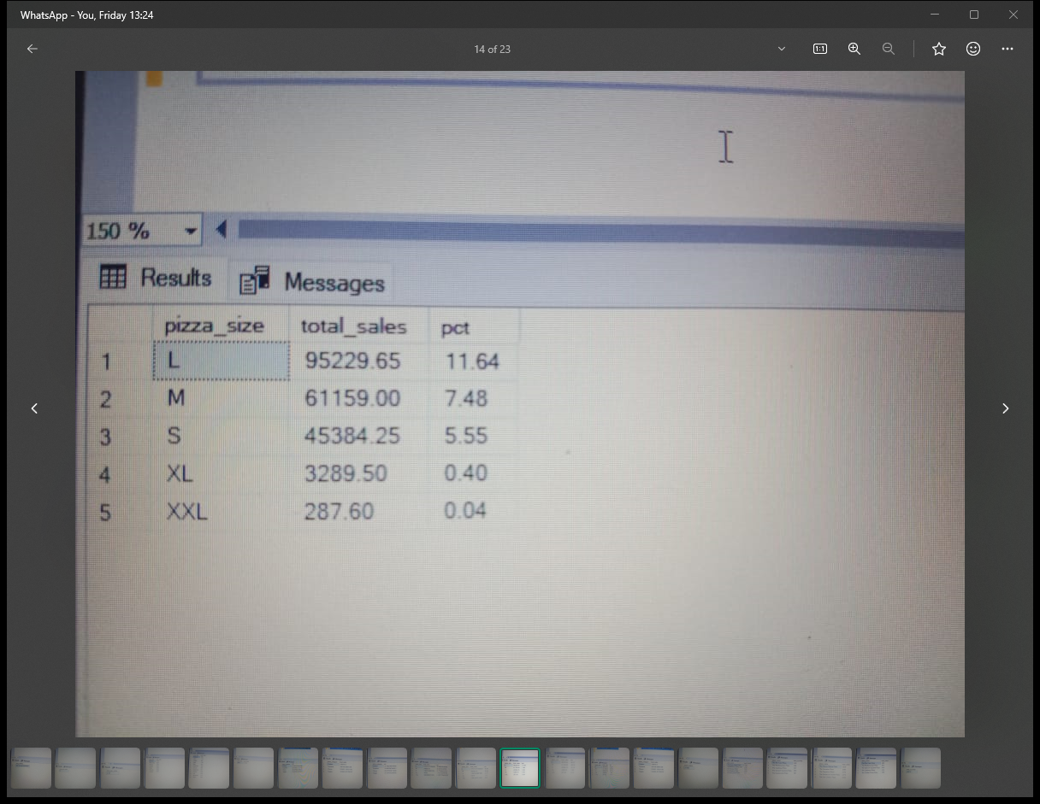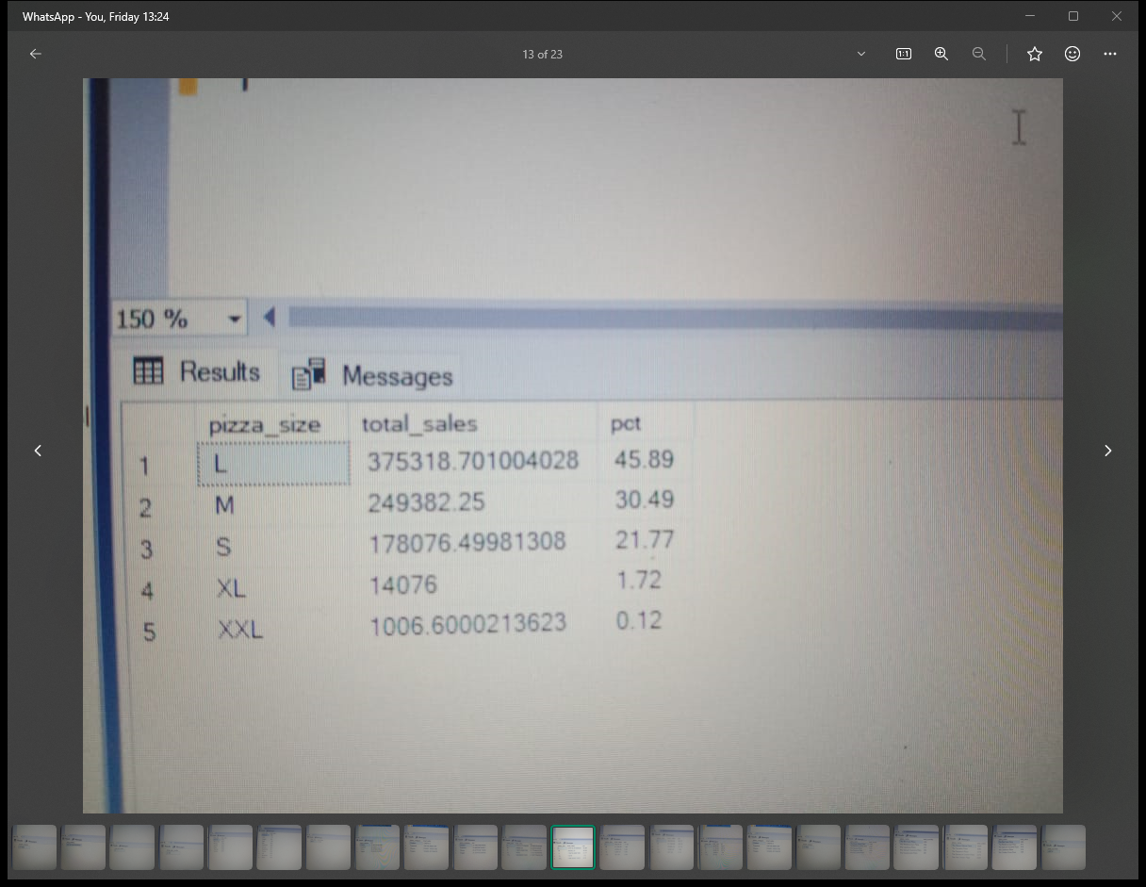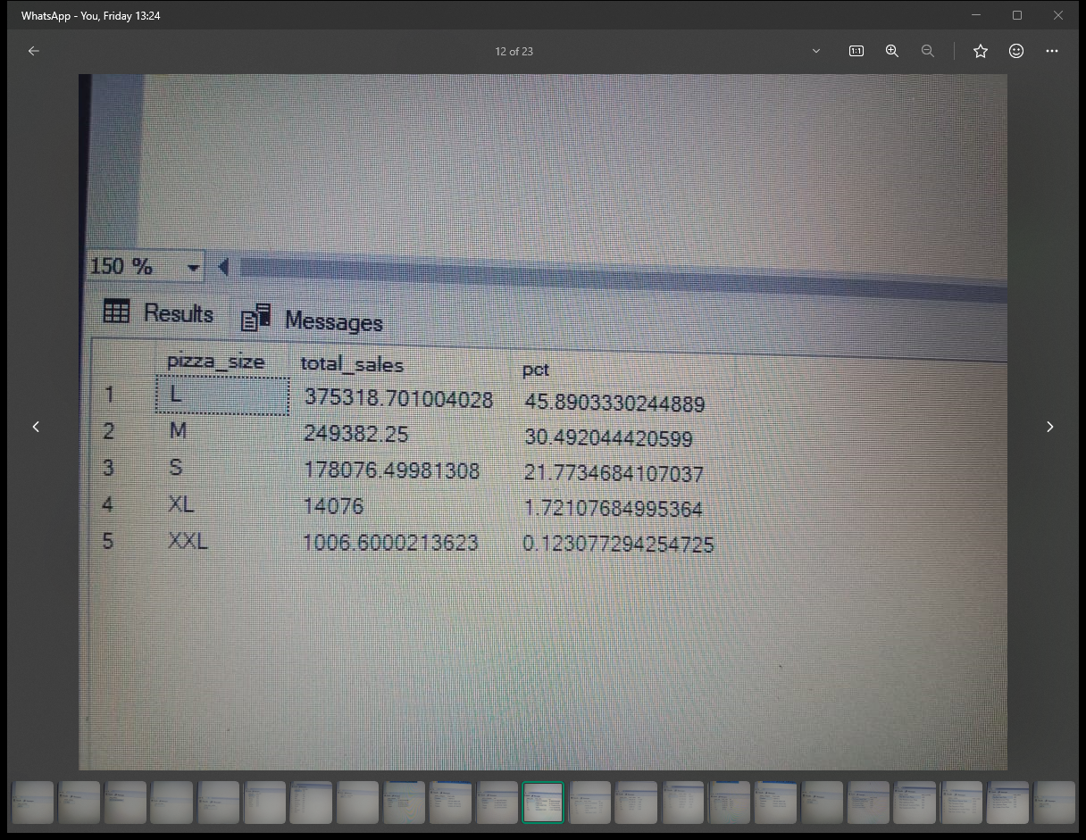ORDER BY PCT DESC

QUARTERWISE

11Q. SELECT TOP 5 PIZZA_NAME,SUM(TOTAL_PRICE)AS TOTAL_REVENUE FROM PIZZA_SALES

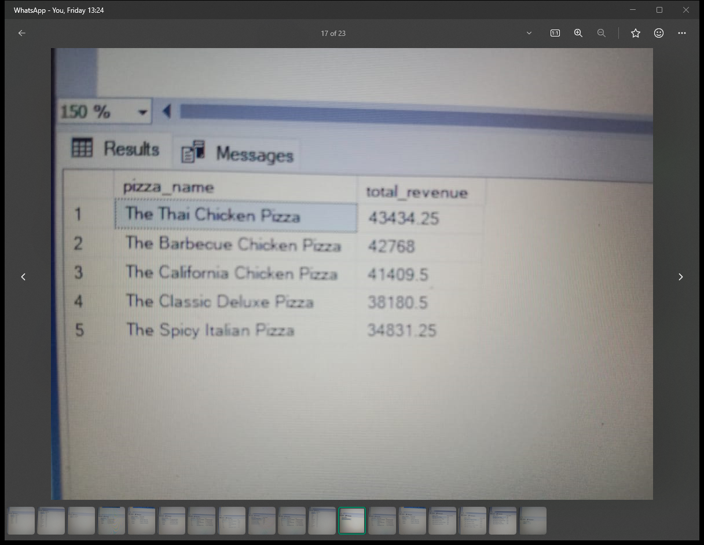ORDER BY TOTAL_REVENUE DESC

12Q. SELECT TOP 5 PIZZA_NAME,SUM(TOTAL_PRICE)AS TOTAL_REVENUE FROM PIZZA_SALES

ORDER BY TOTAL_REVENUE ASC

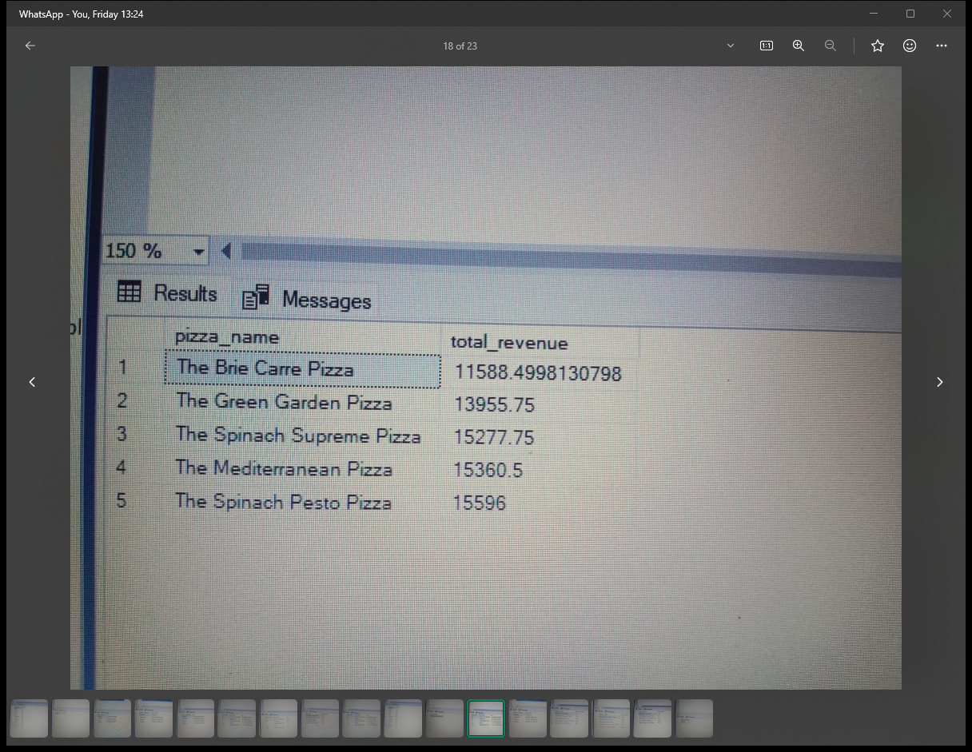

13Q. SELECT TOP 5 PIZZA_NAME,SUM(QUANTITY)AS TOTAL_QUANTITY FROM PIZZA_SALES

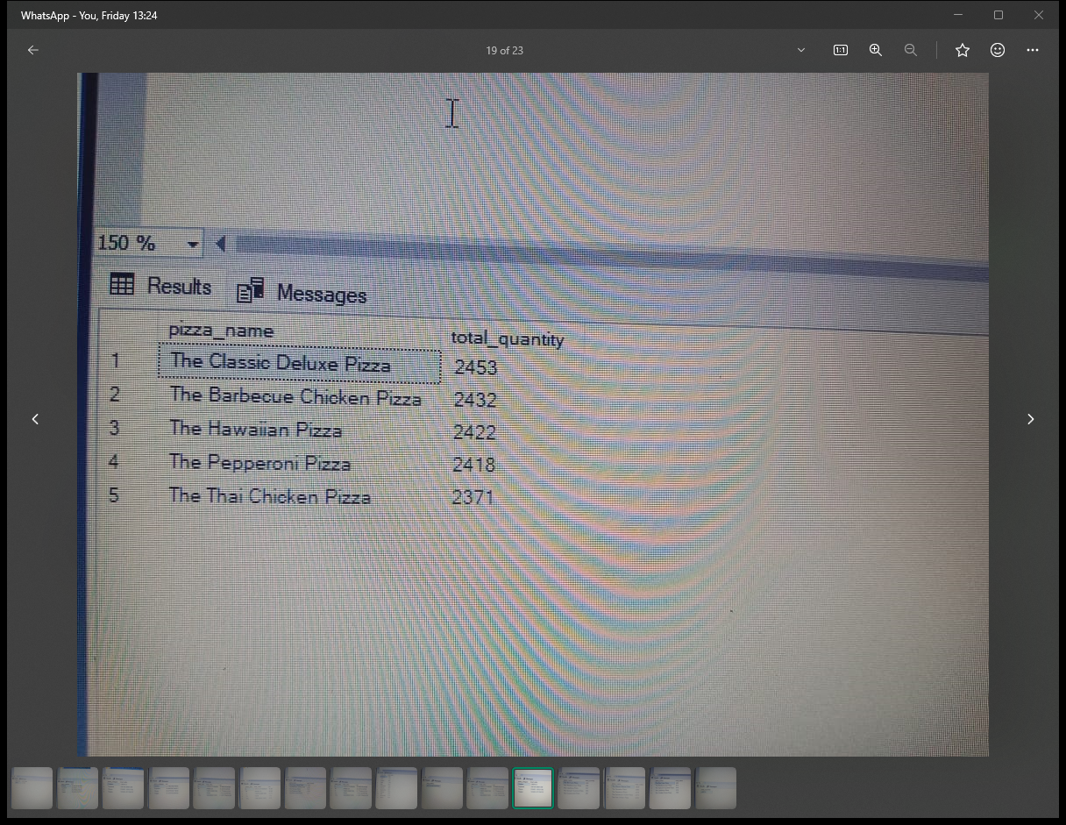ORDER BY TOTAL_QUANTITY DESC

14. SELECT TOP 5 PIZZA_NAME,SUM(QUANTITY)AS TOTAL_QUANTITY FROM PIZZA_SALES

ORDER BY TOTAL_QUANTITY DESC

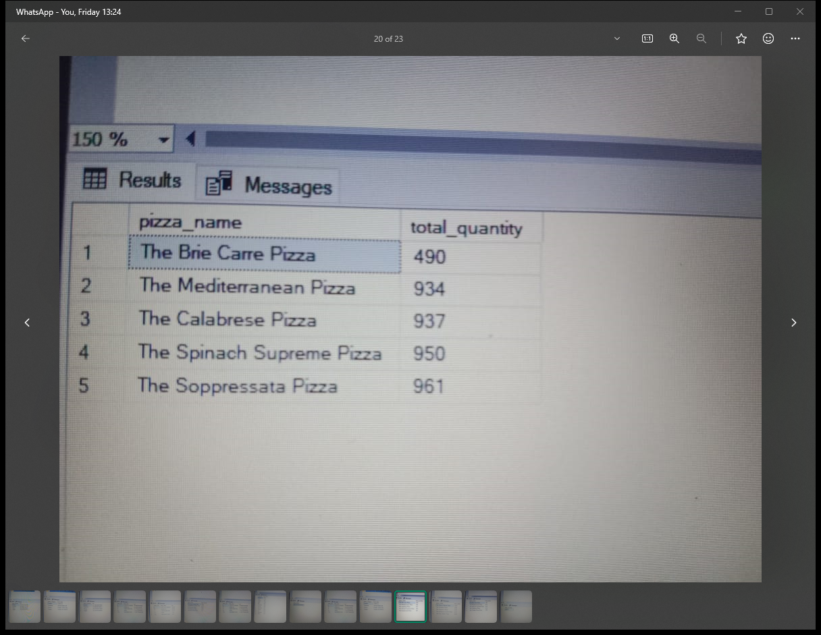

15Q. . SELECT TOP 5 PIZZA_NAME, COUNT (DISTINCT ORDER_ID)AS TOTAL_ORDERS FROM PIZZA_SALES

ORDER BY TOTAL_ORDERS DESC

